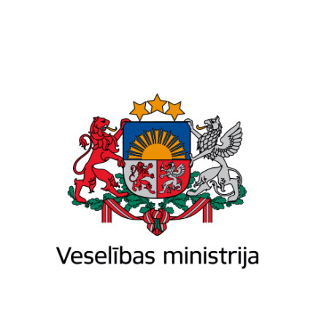

Ministry of Health of the Republic of Latvia

Brīvības iela 72 k-1, Rīga, LV-1011, tālr. 67876000, fakss 67876002, e-pasts pasts@vm.gov.lv, www.vm.gov.lv
Riga

04.07.2024.Nr. 01-19.2/2574

Mr Aurimas Pečkauskas, Vice-Minister of Health, aurimas.peckauskas@sam.lt
Ms Anželika Oraitė, Director of Pharmaceutical Policy Department, Ministry of Health anzelika.oraite@sam.lt
Ms Anniki Lai, Deputy Secretary-General on Health, Ministry of Social Affairs, anniki.lai@sm.ee
Ms Laura Viidik, Advisor at the Department of Medicines, Ministry of Social Affairs, Laura.Viidik@sm.ee
Invitation to the meeting of Baltic high-level working group of critical medicines, Riga, 23 August 2024

Dear colleagues,

Continuing the work of our group and following up on our online meeting held on 10 May, I would like to cordially invite you to our next meeting, scheduled for 23 August 2024. We are planning to convene it in person at the premises of the Ministry of Health of the Republic of Latvia. The provisional agenda is as follows:

- Possible harmonisation of critical medicines lists and stockpiles – information exchange on further steps (tour de table)
- Presentation of the Latvian industry (to be decided*)
- Discussion of forthcoming study visit to Ukraine (to be agreed)
- Discussion of proposals from the Baltic Assembly regarding enhancing cooperation and coordination during emergencies (BA letter No. 1/0624-97 of 18 June 2024) (to be agreed)
* Please let us know if you are willing to have this item on the agenda and include the presentation from Latvian industry on the possible cooperation proposal.

Your feedback and any additional proposals for the agenda are most welcome. In the case you wish to have other experts from your side attend the meeting, please inform us. We intend to start the meeting at 10:00 A.M.; however, we can adjust the starting time to accommodate your travel arrangements to Riga. Kindly confirm your participation by 31 July via e-mail at es@vm.gov.lv.

I look forward to your response and our continued collaboration.

Yours sincerely,

State Secretary | (signature*) | Agnese Vaļuliene

Ludis Pauliņš 67876024
ludis.paulins@vm.gov.lv

